Game Theory for Rebels
A Guide for the Oppressed

Part IV

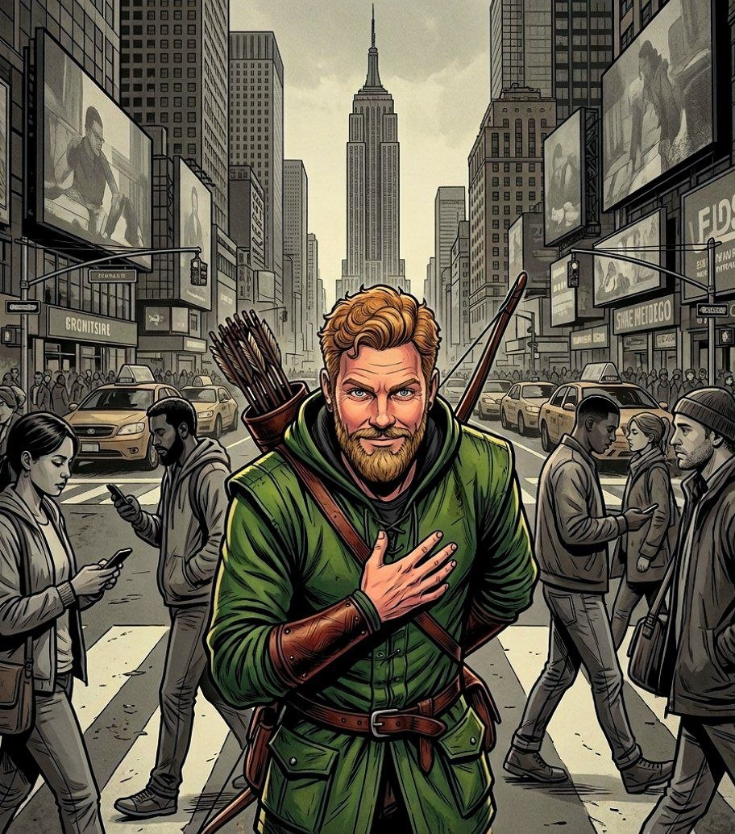

Ropes Pierre

Game Theory for Rebels
A Guide for the Oppressed

Part IV

By Ropes Pierre

Published by:
The Swarm of Strategic Rebels
who Volunteer to share this document.
Copyright Notice (CC BY 4.0)

This work is released into the public domain under the Creative Commons Attribution Licence (CC BY 4.0). You are free to copy, distribute, and adapt this work, on condition that any derivative works or reproductions must properly name and credit the original source/author.

Since the author is anonymous, appropriate credit specifies where the author posts his philosophical work, more specifically https://thepragmaticrealist.substack.com/, and can be in several forms such as:

- "The Pragmatic Realist (Substack)", with or without hyperlink.
- "thepragmaticrealist.substack.com", with or without hyperlink.
- "Ropes Pierre", with hyperlink to Substack or the address displayed.
- "Ropes Pierre via The Pragmatic Realist (Substack)", with or without hyperlink.

Game Theory for Rebels 4: Ephemeral Swarms and Antagonistic Balance

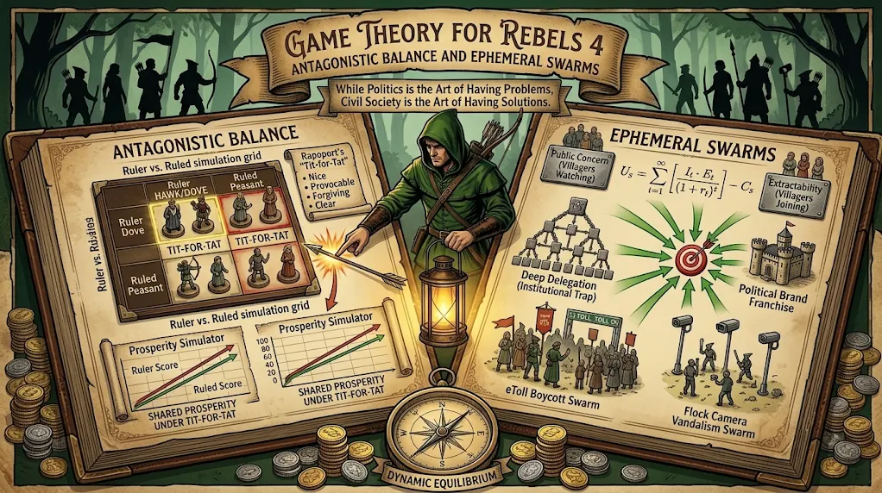
While Politics is the Art of Having Problems, Civil Society is the Art of Having Solutions.
In Game Theory for Rebels 3, we mapped out the various Political Franchises maintained by a Political Brand and explored the mechanics of Democratic Betrayal.
Politicians do not seek to resolve social issues, they treat public interest problems and illicit corruption pipelines as Utility generating assets: Problem Franchises and Corruption Franchises, respectively.
Political Brands use these franchises to extract maximum electoral and monetary value from both the uninformed public and the needy Subverters. A Trade-Off happens at the Median where the Agent switches allegiances to maximise Rent Seeking, resulting in Factional Drift away from Public Preference.
We will now examine the role of Civil Society in collapsing these Franchises by examining the roles of Solution Franchises. Stable Nash Equilibria exist where the Problem and Solution Franchises can work together to extract mutual Utility over long periods of time. However, Solutions Franchises can be structured to avoid that Institutional Trap.
Civil Society represents any non-state actor, activist network, voluntary civilian organisation, or even just an angry group of friends or a single motivated individual. They build Solution Franchises to spread their ideas of solutions to problems while generating the Utility needed to run the campaign.
The difference in Utility extracted from Problem and Solution Franchises around any single problem is called the Balance of Public Momentum, and it represents how polarised a society is about actually resolving the problem.
We will also discuss Ephemeral Solution Franchises to force the resolution of political Problem Franchises without falling into the Institutional Trap of needing the problem to exist to maintain relevance. We will also explore the use of Ephemeral Swarms to drive up costs for an oppressive Ruler population while minimising costs for each individual Ephemeral Solution Franchise.
We will then explain the Hawk-Dove Game and a variant of the Volunteer’s Dilemma called the Ruler’s Dilemma, where the Ruler is more likely to Defect than the Ruled, before explaining how a Tit-for-Tat Strategy optimises the Volunteer’s Dilemma’s outcome, and therefore the Ruler’s Dilemma’s outcome, for both the Ruler and the Ruled.
This leads to the conclusion that the Perceived Value of society is maximised for both Ruler and Ruled when there is an Antagonistic Balance between the two populations. While Might might make Rights, it certainly does not maximise prosperity.

Solution Franchises
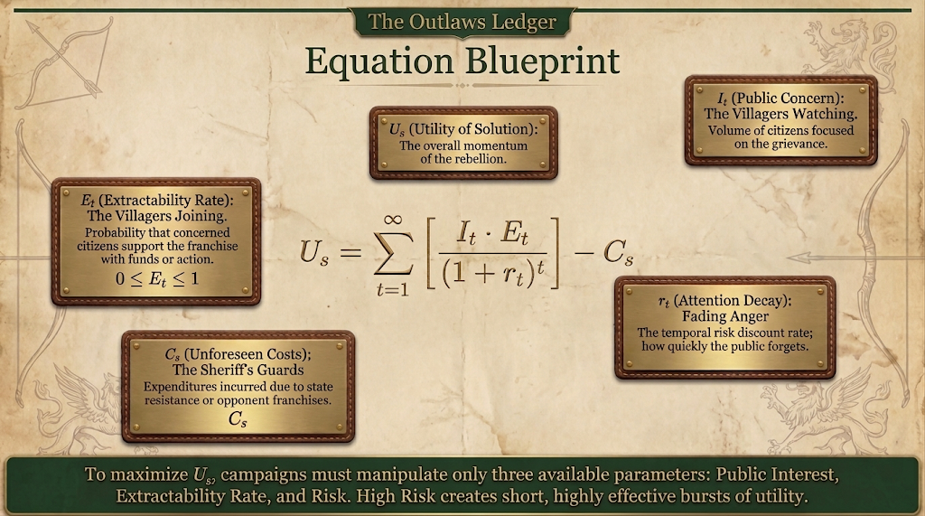
While the political sphere operates as a marketplace of attention, Civil Society is the marketplace of physical action, composed of NGOs, charities, community watchdogs, trade unions, informal interest groups, organised or disorganised citizen networks and individuals acting on their own interests.
Just as a Political Brand maintains Problem Franchises to gather cash flow, votes or voluntarism over an extended horizon, a Civil Society organisation maintains a Solution Franchise to gather donations, votes, and volunteer labour.
The Utility of a Solution Franchise is calculated in exactly the same way that the Utility of a Problem Franchise is calculated, and the only way to distinguish the two is that a Solution Franchise reduces the Utility of a Problem Franchise.
A civil Solution Franchise collapses into a political Problem Franchise the moment its aim is perverted into gathering Utility in favour of, rather than against, a political agenda.
A reasonable campaign only has three parameters that it can meaningfully manipulate: Public Interest, It, the Extractability Rate, Et, and Risk, rt. You cannot control Unforeseen Costs, Cs, for your own franchises.
Public Interest and Extractability Rate need to be maximised. They are determined by how seriously the public cares about the underlying problem, and so this game is played on the level of Public Opinion.
If an individual Solution Franchise struggles to generate enough Utility on its own, parallel groups can combine their efforts in a decentralised way so that the aggregate Utility around the Solution Franchises are maximised via a numbers game.
If you cannot use social media or advertising, due to oppressive restrictions or otherwise, default to graffiti and public tagging for public signalling.
Risk is by far the most important element here. If you play it safe, your Solution Franchise will have a long shelf life but the chance of success is significantly reduced. High Risk Solution Franchises escalate the Risk of the corresponding Problem Franchises, decreasing the Utility of the Problem Franchise.
The Utility of Problem and Solutions Franchises contribute towards each other’s the Unforeseen Costs, Which is related the difference in expected values and observed values of Utility in the past. If either side makes a sudden advance, there is a lag in the other side realising.

The Balance of Public Momentum

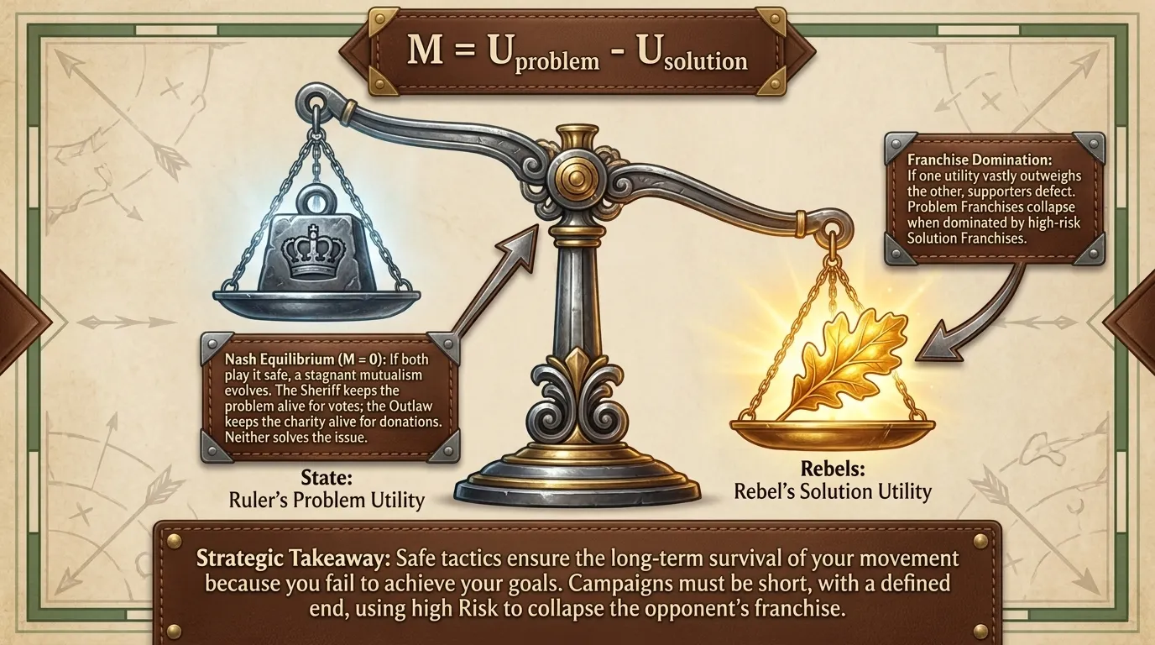
To understand how Civil Society interacts with the state, we must evaluate the net differential between political Problem Franchises and civil Solution Franchises. We define this variable as the Balance of Public Momentum, M.
If the Balance of Public Momentum is at zero, it either implies that the public doesn’t care above a certain baseline, or that the public is divided on an issue. It also goes to zero if a problem and Solution Franchise mutually collapses.
A balanced mutualism can evolve where the politician maintains the grievance as a vote engine while a Civil Society institution maintains a complementary Solution Franchise as a donation engine.
Both organisations coexist in a stable Nash Equilibrium, harvesting resources from the same public issue without ever resolving it, sacrificing high Utility to ensure the survival of the franchises.
If the Risk of a Solution Franchise is High, its Utility tends to zero over time, and the only Nash Equilibrium available at M = 0 is if the Utility of both Problem and Solution Franchises tend towards zero. High Risk Solution Franchises escalate the Risk of the corresponding Problem Franchises.
If the Utility of a Problem Franchise is much larger than the Utility of a Solution Franchise, or vice versa, we say that the one franchise dominates the other.
In Franchise Domination, the Utility that one franchise gets from Public Interest and Extractability in terms of voluntary action of cash flows outweigh the other franchise to the point where supporters begin to Defect to the more popular side.
Problem Franchises always collapse if dominated, but Solution Franchises tend to start off in a dominated position and tend to collapse if they fail to capture Public Opinion. If a Problem Franchise collapses, the Rulers will try to extract Goodwill from implementing the solution.
The main strategic takeaway here is that campaigns need to be intended to conclude at a defined end goal, and needs to use high Risk tactics to ensure that its energy is used in effective bursts.
Safe tactics ensure the long-term survival of your movement, but such survival only happens because you fail to achieve your goals. If you play it safe, you make the game safe for your opponent too.
Some problems are continuously generated, and so not all Problem and Solutions Franchises can be collapsed entirely.
A good example is charities for the homeless. While homelessness can be reduced, circumstances are not always fortunate and so new homeless people are constantly being generated. High homelessness is damaging to a political brand, but only charities have the networks to actually deal with the issue on the ground.
Mutualism between Problem and Solution Franchises tends to be motivated politically and socially by its impact on the Utility of Goodwill.

Ephemeral Swarms

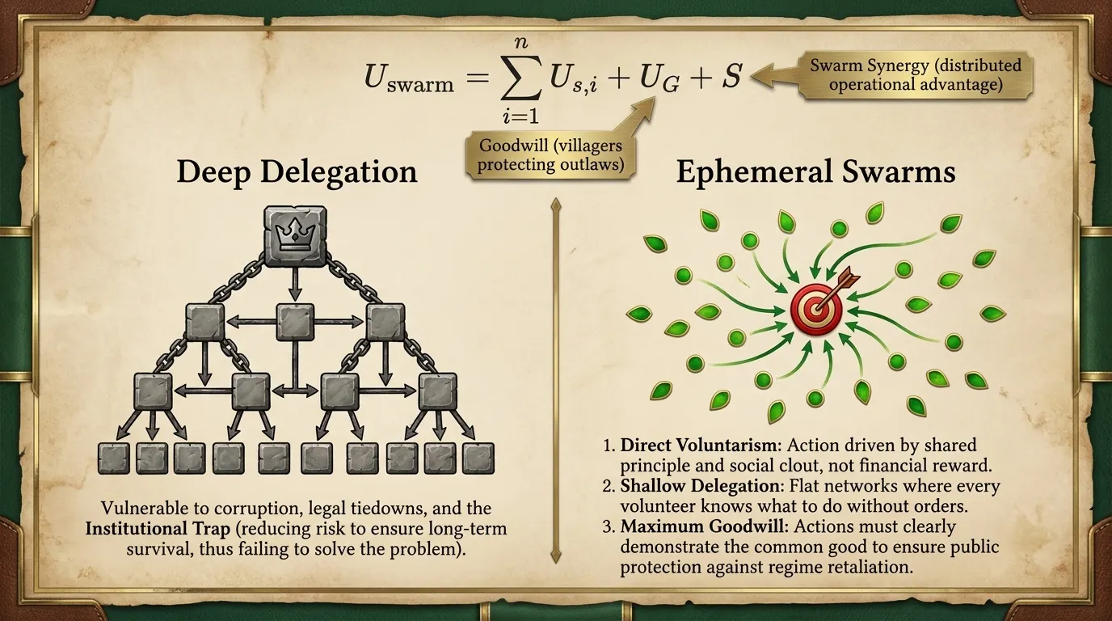
In the context of an oppressive regime, there is often extremely high Risk involved with Solution Franchises, in extreme cases your life may even be threatened.
Since the Utility of an individual Solution Franchise is minimised by Risks, it is often not reasonable to organise into official organisations that can be pointed to and targeted for crack downs.
Instead, movements have historically taken on the form of Ephemeral Swarms. An Ephemeral Swarm is a multi-front proliferation of decentralised, single-issue campaigns that pop up simultaneously around one issue, is sustained by voluntary action, and then dissolves upon completion or failure of the campaign.
Even if the Swarm fails, it still reduces the Utility of Political Brands by altering Public Opinion and political Risk calculations.
Because each unit in the Swarm maintains zero delegation depth and relies on direct voluntary labour, the Swarm has no permanent overhead to defend and no administrative hierarchy for the regime to corrupt or tie down in court. The Risk is spread out.
The Utility of an Ephemeral Swarm, shown above, is the sum of the Utilities of the participating Solution Franchises, the Utility of Goodwill towards the Swarm’s activism, UG, and a Swarm Synergy term, S.
Ephemeral Swarms can attack either Problem or Corruption Franchises, driving up the Risk and Unforeseen Costs. It escalates the Risk by bringing intense focus to the issue. Unforeseen Costs are unforeseen because they weren’t taken into account during your Risk assessment, and so expected values do not match observed values.
The Utility of Goodwill represents the general public’s attitudes towards the Swarm and the issue it formed around. This determines things like whether or not the public is likely to protect a volunteer if caught or to encourage voluntarism.
The Swarm Synergy term accounts for things like the added Utility of parallel, distributed operations compared to linear, hierarchical operations.
Swarms that are not ephemeral, or that stabilise into formal organisations are in danger of falling into the Institutional Trap: the phenomenon where established institutions reduce the Risk of their strategies to maximise donor and volunteer interest over time. High Risk strategies are more likely to work, but if the problem goes away the institution looses its reason to exist.
In order to inspire the formation of Swarms, civil movements need to master three aspects of decentralised organisation.

Promote Direct Voluntarism:
Since formal organisations can be dangerous under an oppressive regime, Civil Action needs to be voluntary. The formation of Ephemeral Swarms relies on a culture of Voluntarism, ensuring participants offer direct physical, intellectual, or Cooperative action out of a shared principle.
There needs to be clout associated with participating, it is by far the most effective mechanism for overcoming Risk aversion, when observing historical struggle movements. A high volume of signalling, via social media posts or physical tagging, can also encourage Voluntarism.

Minimise Delegation Depth:
Delegation chains must be kept shallow and flat. Every participating individual or group needs to know what to do without being ordered to do it.
We will analyse Flock Camera Vandalism in the next section as an example of a spontaneous Swarm, but it is worthwhile to point out here that signalling happens via flyer posting or social media posts, and only ever stays signalling. Everything has to be clear to a Volunteer before he decides to join the Swarm.

Maximise the Utility of Goodwill:
In the historically-rooted story of Robin Hood, the villagers understood that the Merry Men were acting in their interest, and so were willing to risk the death penalty protecting them. This Goodwill was generated by stealing the predatory taxes and giving them back to the oppressed, which simultaneously escalated the cost of oppression.
Without enough of the public on its side, an Ephemeral Swarm is unlikely to form in the first place. It is therefore vital to master the ability to communicate the common good of the campaign, bearing in mind that actions speak louder than words.

Modern Examples of Ephemeral Swarms

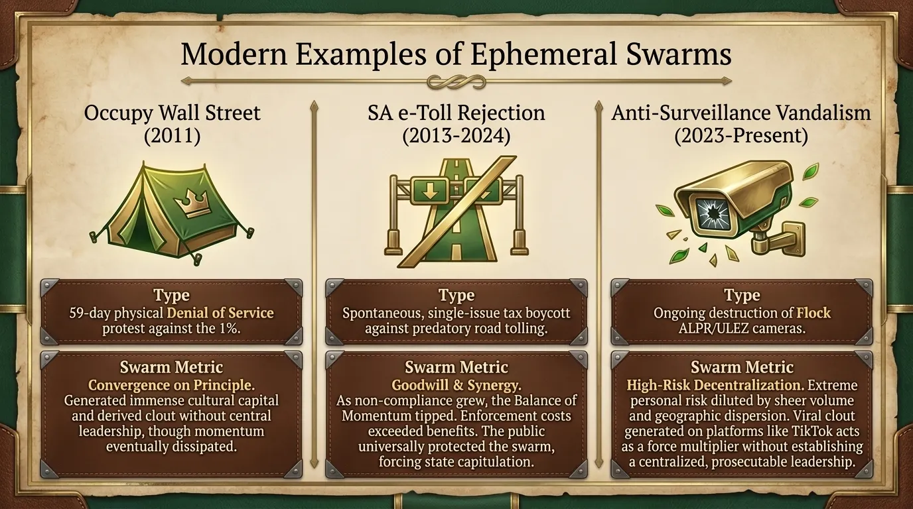
To demonstrate that Ephemeral Swarms are actual phenomena, we will look at three modern examples of movements that operated at various levels of personal Risk to each Volunteer, and lasting either months or years: Occupy Wall Street (unsuccessful), the South African e-Toll rejection (successful tax revolt), and the vandalism of automated surveillance cameras, such as the public rejection of Flock cameras (ongoing).
Despite their different contexts, these movements share fundamental structural similarities that define the operational mechanics of an Ephemeral Swarm:

Principle-Driven Mobilisation:
None of these movements rely on institutional careerism or paid organisers. Action is driven by shared principles regarding economic fairness, tax consent, or personal privacy. Generally speaking, the principle is that the masses do not consent, and so vocalising this often can be useful.

Social Clout and Cultural Capital as Incentives:
In place of financial rewards, participants derive immense personal pride, social clout, and cultural capital from participation. This is often amplified through public visibility, viral social media trends, or community solidarity.

Decentralisation and Risk Mitigation via Saturation:
Each movement dilutes or bypasses state retaliation through sheer volume, geographic dispersion, or micro-group stealth, not through legal defences – although it helps to have lawyers come out and declare support, which was vital to the success of the BLM riots.

Elimination of Agency Costs:
By avoiding central bureaucracies and maintaining shallow delegation depth, Ephemeral Swarm movements prevent institutional capture, allowing them to remain agile and focus entirely on imposing friction against target franchises.
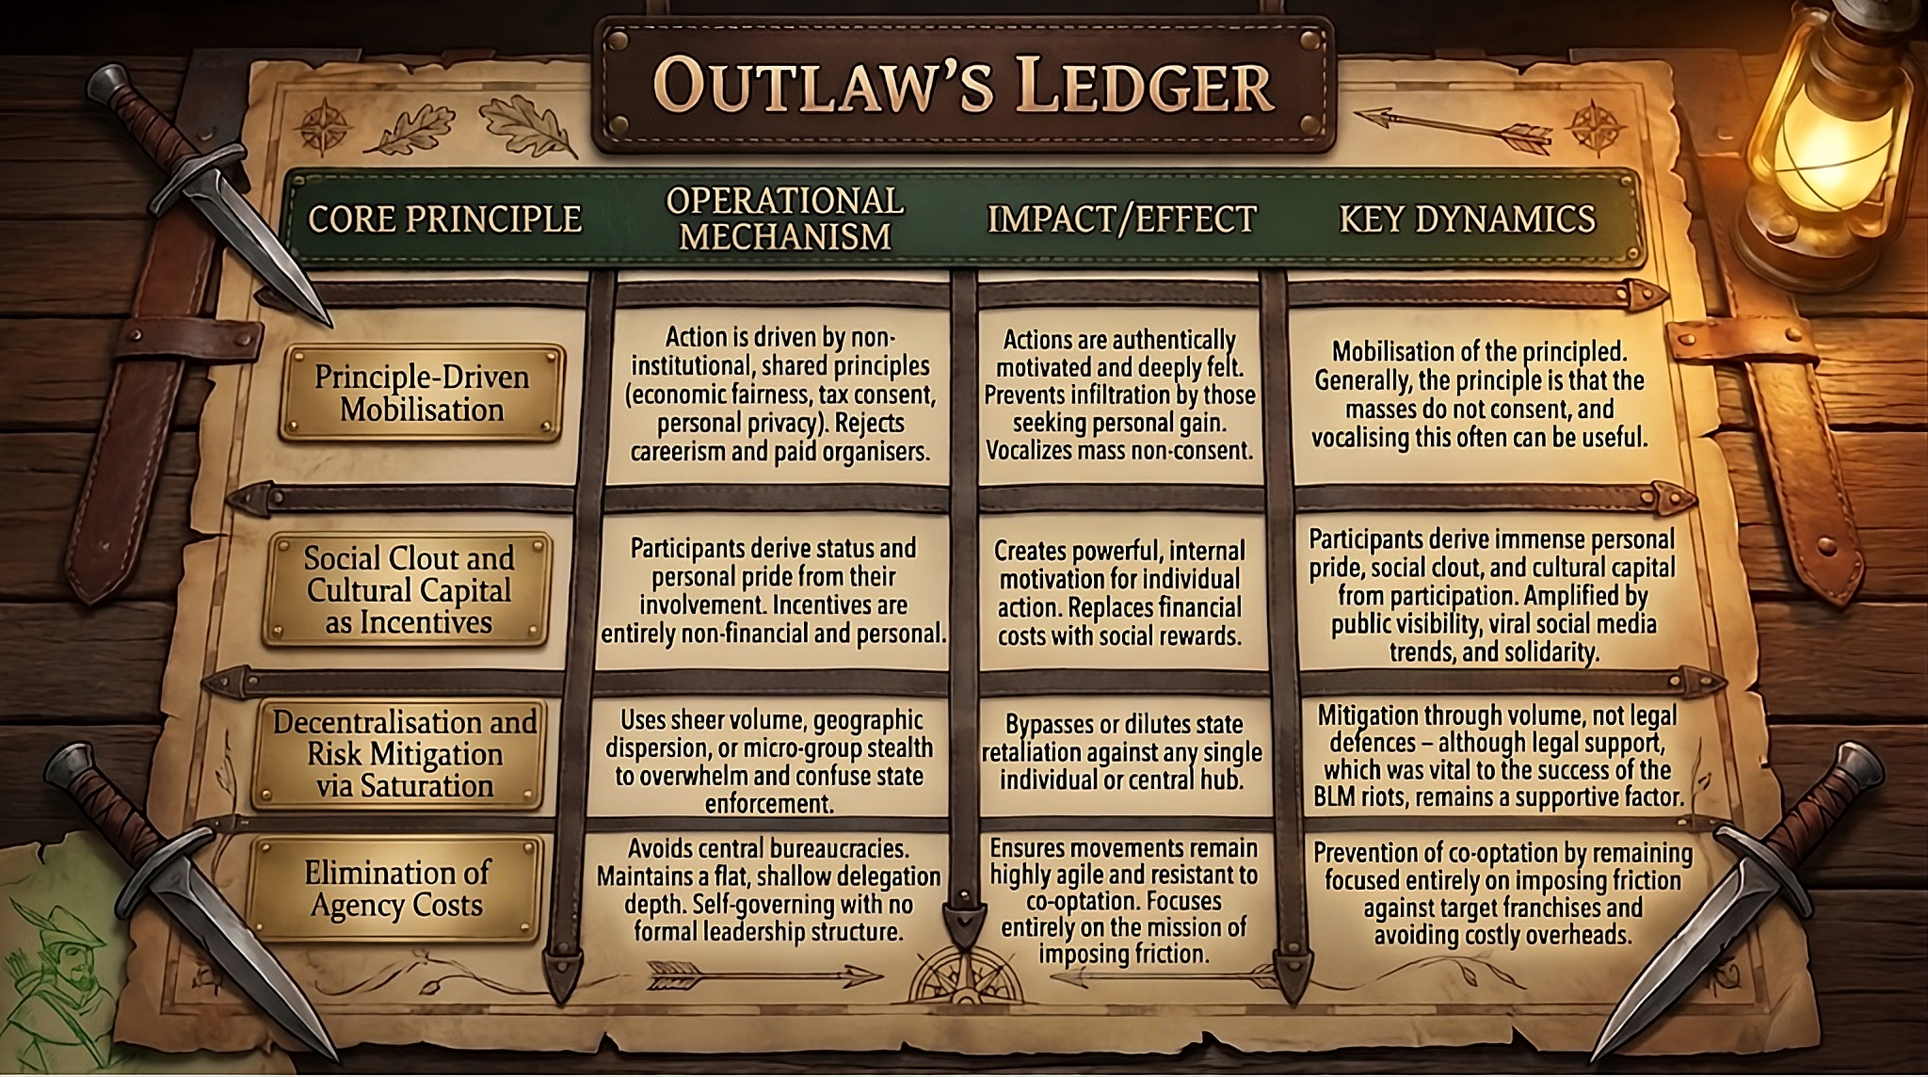

Occupy Wall Street: Convergence on Principle and Derived Clout
Occupy Wall Street was a Denial of Service Protest in the form of a physical occupation of Wall Street that ran from 17 September to 15 November 2011 – 59 days. Highly disparate interest groups ranging from anti-debt activists to labour advocates, across political divides, converged around a single issue: economic inequality, corporate greed, and the influence of money in politics.
They blamed this on the 1% wealthiest individuals and families, the oligarchs of Wall Street, and so they acted as a collective to impose costs on Wall Street through a Denial of Service protest.
Rather than coalescing around a formal central command or long-term institutional hierarchy, participants operated based on shared core principles against financial extraction. Participants derived significant social clout and cultural capital simply from their physical presence and active participation, driving viral visibility and inspiring parallel encampments worldwide before the initial momentum dissipated.
It failed because it was a single, localised campaign that concluded when the camps dispersed due to friction costs.

South African eToll Rejection: The Single-Issue Tax Revolt
In 2013, motorists in Gauteng, South Africa began to spontaneously boycott the SA National Roads Agency’s e-Toll system – an automated, camera-based road tolling system. This was a remarkably successful tax revolt where the general public was entirely resistant to any threat of action by the state. It was also remarkably prolific, with the state only declaring defeat and cancelling the program in 2024.
Ordinary citizens faced non-compliance risks, including theoretical legal prosecution and financial penalties. However, because motorists acted on principle against predatory infrastructure extraction, participation grew into a massive Swarm of individuals refusing to comply.
Once the state’s initial threats failed, subsequent threats lost their impact and the Swarm only grew – mainly because of the Utility of Synergy and Goodwill. Each individual faced enormous personal Risk and so the value of the individual Solution Franchises was low.
Once Goodwill started growing towards the campaign, the entire dynamics was driven by Goodwill – the public agreed with the Swarm. Because of that Goodwill, there was an enormous clout and personal pride in participating in the Swarm.
As the Swarm grew, the Balance of Public Momentum reached a point where the cost of enforcement became higher than the benefit of enforcement. It therefore became safer to participate, driving up the Utility of Synergy.
People who paid the tax became outliers, and the state had no choice but to abandon the policy.

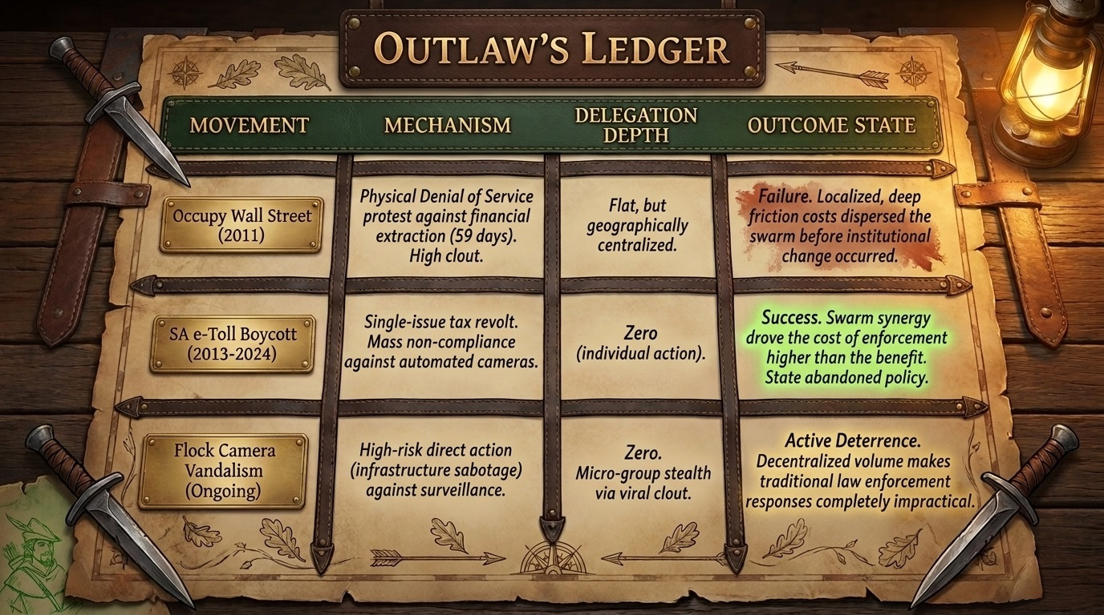

Flock Camera Vandalism: High-Risk Direct Action and Viral Clout
The best example of recent, ongoing Ephemeral Swarms is the widespread sabotage and vandalism targeting automated surveillance infrastructure, such as Flock Safety ALPR (Automatic License Plate Reader) camera networks, which started around April 2025, and the anti-ULEZ (Ultra-Low Emission Zone) camera Swarm, which started early in 2023, who call themselves the Blade Runners.
Because disabling surveillance hardware carries high direct legal Risk, individual Solution Franchises tend to be small-scale, often consisting of just one individual or a small group acting rapidly in their local area and then disappearing.
Despite the high risk for any single actor, the high volume and diversity of individual participants makes traditional law enforcement responses completely impractical, made worse by the fact that there are no leaders, only Volunteers.
The participants act out of strict principle regarding privacy and civil liberties, while social media platforms like TikTok serve as force multipliers for clout generation and Goodwill signalling. Suggestive statements are used to give ideas on what forms Volunteer activism can take, without explicitly calling for the law to be broken – shared via physical or digital flyers.
The fact that citizens are willing to break the law to make it clear that they do not consent should scare the Rulers, because any action performed once is practiced, and with more practice comes more skill. I therefore predict that the Swarms will win in these cases…

Antagonistic Balance:
The Bridge to Game Theory

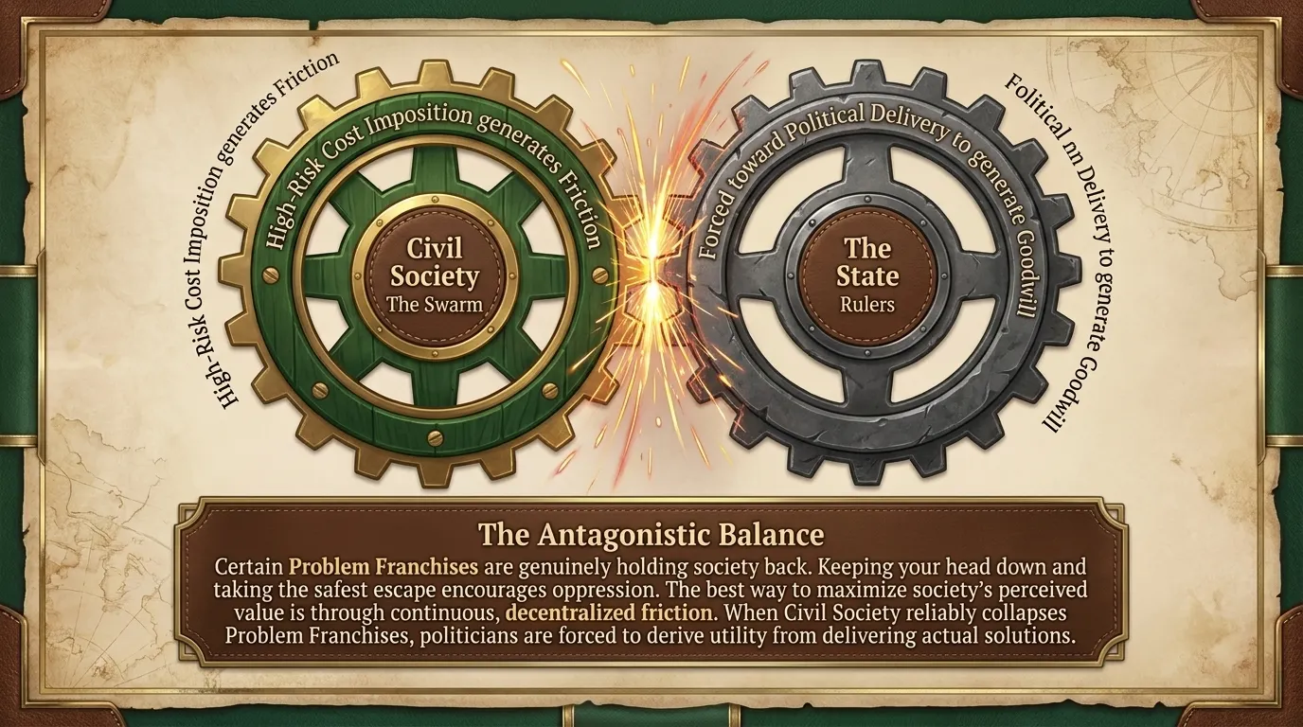
Certain societal problems, such as environmental stewardship, public health, national defence, and civil liberty protection, are continuous features of human organisation.
Unfortunate circumstances will always be a factor, and so certain Problem and Solutions Franchises need to Cooperate. This is usually the case for charities that provide a service to an affected community, such as soup kitchens, disaster relief programs, homeless shelters, and so on.
Other times the Problem Franchises are genuinely holding back or hurting society. In these cases, the Pay-Offs need to be minimised by maximising Costs. Ephemeral Swarms can be used to force the dissolution of a Problem Franchise and the implementation of a solution, thus addressing the underlying conflict between an oppressive Ruler population and the Ruled population that arises from Democratic Betrayal.
We also need to consider the fact that hasty implementation can lead to unforeseen consequences, and so the fact that Problem Franchises delay the implementation of solutions is not problematic in itself. It provides time for debate and extrapolation. However, politicians tend to preserve their franchises unless they are forced to move on.
If Civil Society constantly steps in and ensures the dissolution of Problem Franchises, and we assume that corruption has been dealt with, it forces a situation where politicians need to derive the bulk of their Utility from Goodwill, which means delivering on promises and providing visible improvements to the standards of living of the poorest half of the nation.
This results in an Antagonistic Balance, where Civil Society imposes Costs on the Ruled class through Civil Action, such as Ephemeral Swarm campaigns.
Contrary to common belief, the best way to live in a society is not to keep your head down and take the safest escape at every opportunity, that only encourages oppression. In the next few sections we will explore three basic games to explain why this is the case. Tit-for-Tat dominates every other Strategy when it comes to maximising shared value.
We will now try to demonstrate that it is also the best approach to maximising Perceived Value in a society with a Ruler population and a Ruled population. In doing so, we will attempt to prove that living in Antagonistic Balance produces the greatest prosperity for both Ruler and Ruled populations simultaneously.

The Hawk-Dove Game:
Shared Resource Competition

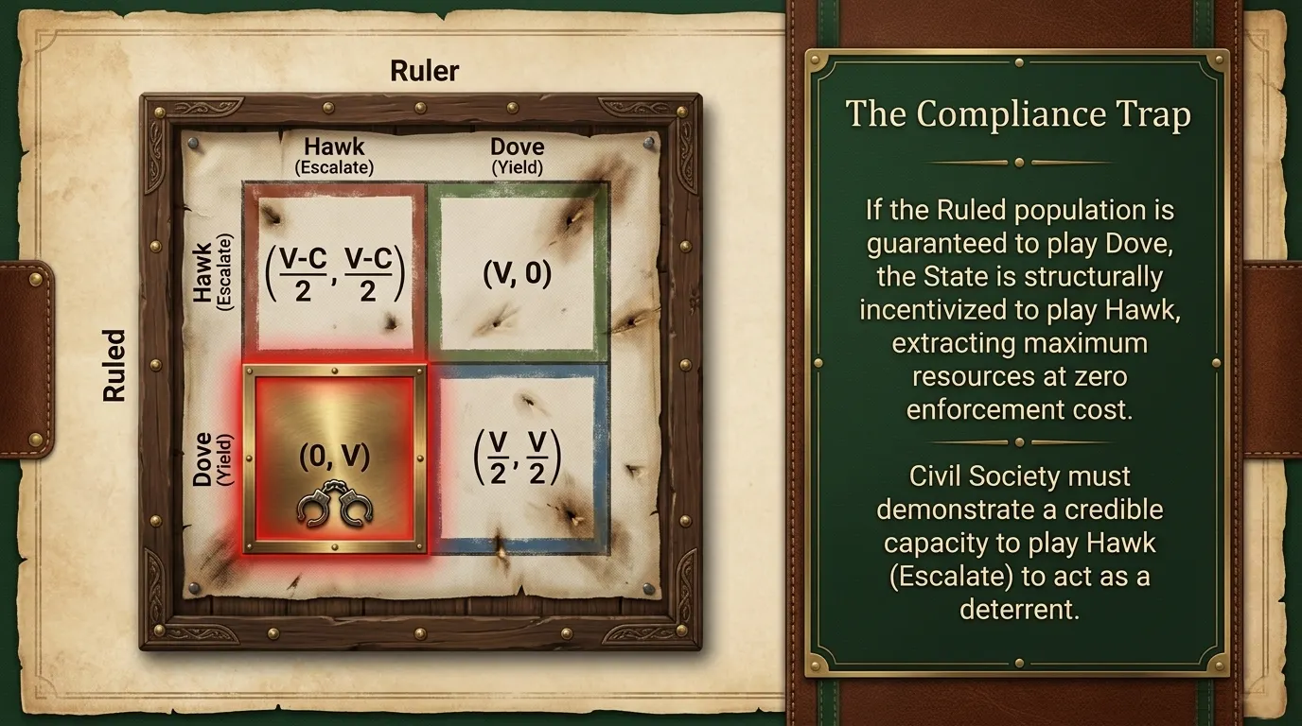
The Hawk-Dove Game was originally formulated in 1973 by evolutionary biologists John Maynard Smith and George R. Price. It is a variant of the Game of Chicken.
The Hawk-Dove Game is a means of explaining conflict behaviours between animals contesting a resource without necessarily fighting to the death.
The model also provides a foundational framework for understanding strategic confrontation over contested public goods, policy decisions, or civil liberties. It can also model conflicts between corporations.
A Hawk has an aggressive Strategy and is always willing to risk an escalatory confrontation, regardless of the cost. A Dove has a submissive Strategy, yields immediately if confronted by a Hawk, and is willing to Cooperate and share value.
We will explain the Hawk-Dove Game in terms of the Ruler vs the Ruled. Both the Ruler and the Ruled have to live in the same society, and so the Perceived Value of society is a shared value, V.
If they both play Dove, they both derive equal value from society. In a single-round game, this means they split the value 50/50.
If both play Hawk, they also share the value, but it has now decreased proportionally to the cost of conflict.
If a Hawk meets a Dove, the Dove walks away with nothing and the Hawk takes the full value without cost penalties.
If the Ruled population is guaranteed to behave like a Dove, the state is structurally incentivised to play Hawk, extracting maximum resources at zero enforcement cost and accelerating systemic decay. This phenomenon is called the Compliance Trap.
To break out of the Compliance Trap, Civil Society must demonstrate a credible capacity to play Hawk when the state overreaches. The capacity of Civil Society to play Hawk is a factor in the Ruler’s calculation of potential Costs, and therefore acts as a deterrent to overreach or oppression.

The Prisoner’s Dilemma

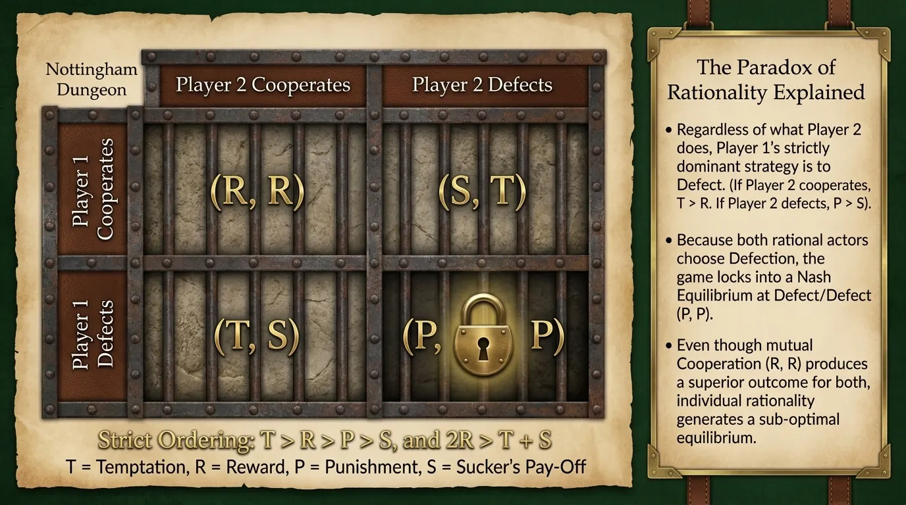
The Prisoner’s Dilemma was developed by Merrill Flood and Melvin Dresher in 1950. They were working on Game Theory at the RAND Corporation during early research into Nuclear Strategy during the Cold War. The scenario was then formalised into its iconic criminal interrogation narrative by Albert W. Tucker.
The classic scenario involves two criminal suspects who have been arrested for a crime that they did commit. Since there is not enough evidence for a conviction, each prisoner is independently offered a plea bargain: Cooperate with your partner (remain silent) or Defect on your partner (testify for the prosecution).
If both Cooperate, neither can be charged for the crime, and in the real world the police would beat them up and let them go. If both Defect, they both receive a reduced sentence. If only one Defects, he gets away free and the other faces the full charges for the crime.
The Pay-Off matrix is governed by four standard outcomes: the Temptation to Defect, T, the Reward for mutual Cooperation, R, the Punishment for mutual Defection, P, and the Sucker’s Pay-Off for unilateral Cooperation, S.
For a Pay-Off matrix to constitute a true Prisoner’s Dilemma, two mathematical conditions must hold: strict ordering, T > R > P > S, and mutual Cooperation is the superior outcome: 2R > T + S.
The fundamental paradox of the Prisoner’s Dilemma lies in the conflict between individual rationality and collective rationality. Even though both Prisoners could be Rewarded for Cooperating, rationally the best Strategy in a single round game is to Defect.
If Player 1 Cooperates, Player 2 receives a Reward by Cooperating, but is Tempted to Defect. Since Temptation > Reward, Defecting is the better Strategy.
If Player 1 Defects, Player 2 receives a Sucker’s Pay-Off if he Cooperates, but a reduced Punishment for Defecting. Since Punishment > Sucker’s Pay-Off, Defecting is the better Strategy.
Because the matrix is symmetric, Defection is the strictly dominant Strategy for both Players regardless of the other’s choice. Consequently, both rational actors choose Defection, leading to the Nash Equilibrium at Defect/Defect.
However, because Reward > Punishment, mutual Defection produces a worse outcome for both Players than mutual Cooperation. Individual rational choices generate a sub-optimal equilibrium for both players.
However, when Players are allowed to retaliate in multi-round games, it is possible to force a Strategy of mutual Cooperation. The most powerful Strategy that we know for this is called Tit-for-Tat.

The Ruler’s Dilemma and The Ruler’s Fallacy
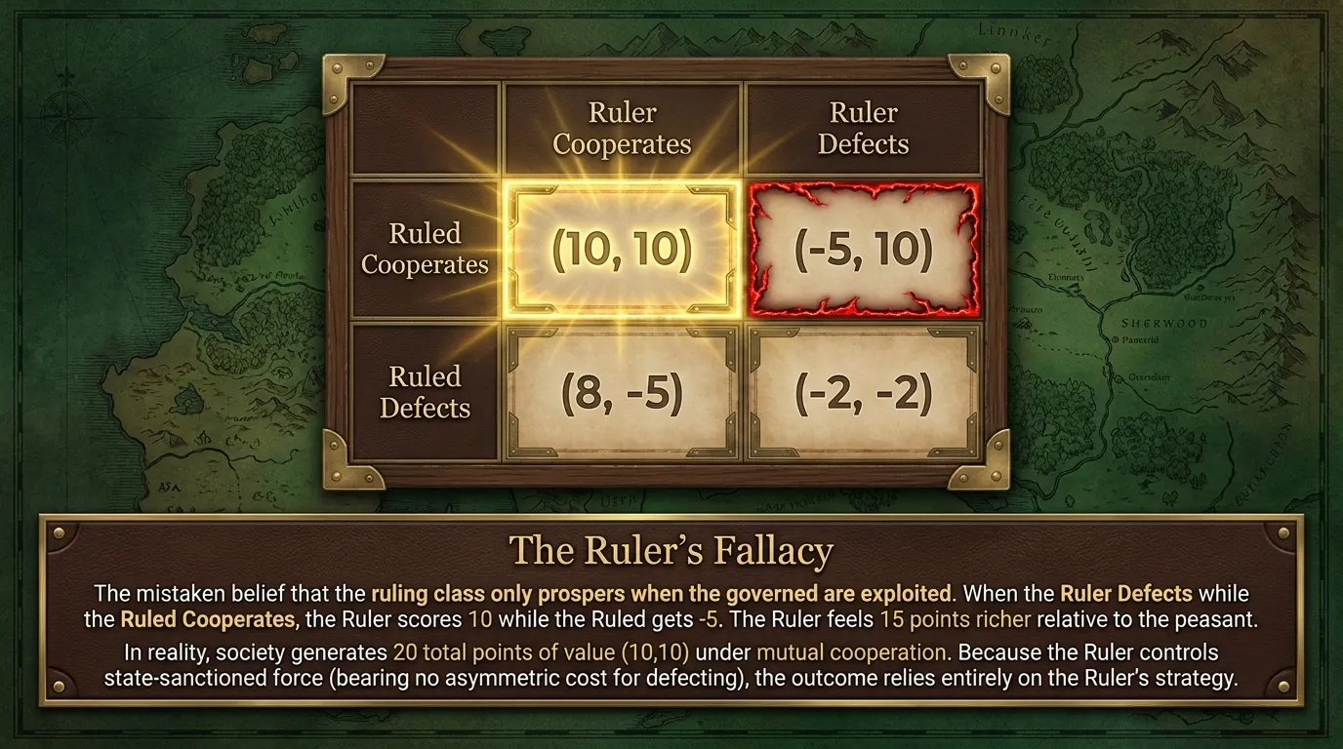

The Ruler’s Dilemma was derived by adapting the structural mechanics of the Prisoner’s Dilemma to the asymmetric power relationship between a governing authority (the Ruler) and a governed population (the Ruled).
For both Ruler and Ruled, we set Reward = Temptation to account for the fact that you cannot gain extra value by Defecting in a healthy society. Then we apply a small Cost asymmetrically to the Ruled if they Defect but not to the Ruler, since the Ruler controls the use of state-sanctioned force.
The Ruler and the Ruled face unequal operational friction, administrative mechanisms, and enforcement costs when making strategic choices. If they both Cooperate they get the best outcome; if they both Defect they both experience a Penalty. If only one Defects, it causes severe damage to the other, much like in the Stag Hunt.
It makes no difference to the Ruler’s individual Pay-Off which direction he chooses in a single-round game, but society misses out on the total Perceived Value that it could have had, 20 points, if he Defects. This would give society only 5 points in total if the Ruled Cooperates, but the Ruler feels 15 points richer than the Ruled.
If the Ruler Cooperates, the Ruled has more to gain from Cooperating, 20 points, than Defecting for only 3 points of value for Society.
If the Ruler Defects, the Ruled is also incentivised to Defect, reducing their personal costs form -5 points to -2 points, and since Defect/Defect gives both sides -2, it also feels more fair, and therefore more rational for a decision maker.
The Ruler’s Dilemma directly addresses a foundational error in politics: The Ruler’s Fallacy. The Ruler’s Fallacy is the mistaken belief that the Ruling class can only prosper when the governed are exploited, driven by the fact that rich people look richer when the poor get poorer.
In reality, the whole society benefits the most when both Ruler and Ruled populations Cooperate, yielding steady tax revenue, civil order, lawful commerce, and flourishing human capital in an environment of minimal Agency Costs.
Therefore, the outcome of the Ruler’s Dilemma is determined entirely by the Strategy that the Ruler adopts, and the Ruled is merely picking the response that minimises personal costs.

Tit-for-Tat: Shared Value Maximisation
in Multi-Round Games

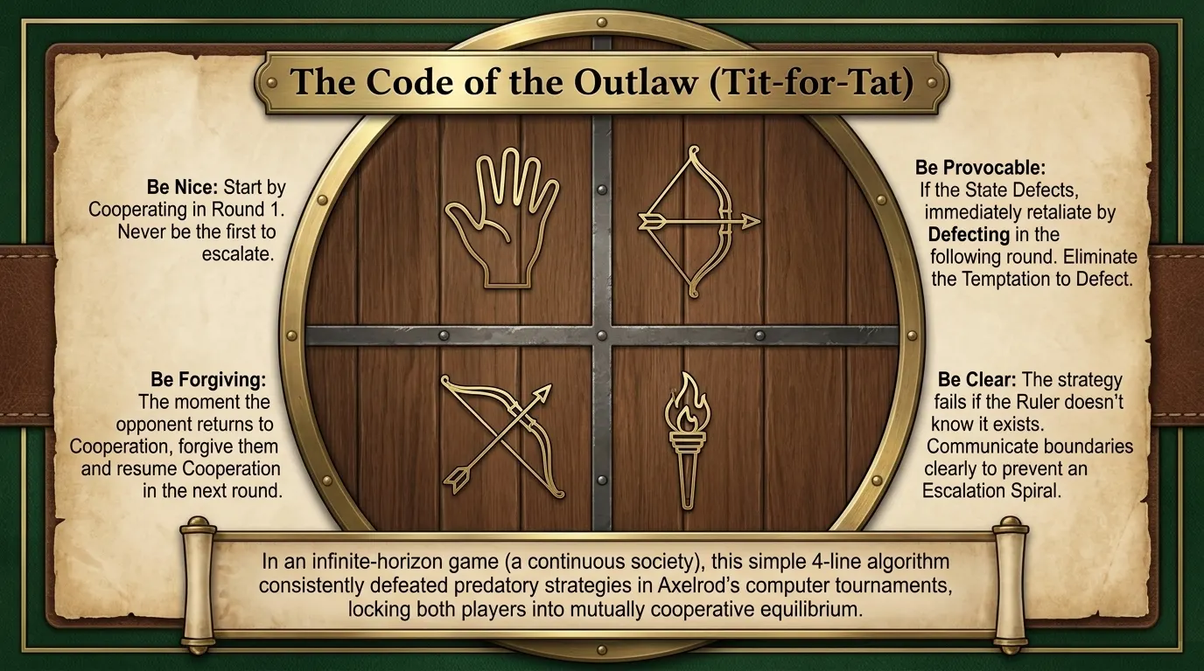
In a one-round game of Prisoner’s Dilemma, mutual Defection is the mathematically dominant Strategy. However, when the game is repeated across multiple rounds, the horizon opens to mixed strategies and reciprocal feedback mechanisms. Society exists as long as the game does not end, and so we describe it as an infinite-horizon game.

The Axelrod Computer Tournaments
In 1980 and 1984, a political scientist called Robert Axelrod hosted his famous Computer Tournaments, where he challenged game theorists, economists, and mathematicians worldwide to submit computer algorithms to compete in an Iterated Prisoner’s Dilemma, with the aim of optimising the outcome of the Prisoner’s Dilemma.
Submissions ranged from ultra-complex Mixed Strategy algorithms that used statistical models to predict opponent Defection rates, to predatory algorithms that actively exploited non-retaliating opponents.
Tit-for-Tat, the winner of the both tournaments, was submitted by mathematical psychologist Anatol Rapoport.
It surprised everyone. It was the simplest entry, only four lines of code, and it consistently defeated every complex algorithm and won both tournaments. Furthermore, it resulted in the optimal outcome for both Prisoners.

Four Rules of Tit-for-Tat:
Be Nice: start by Cooperating in Round 1.
Be Provocable: if the opponent Defects, immediately retaliate by Defecting in the following round of the game.
Be Forgiving: as soon as the opponent returns to Cooperation, forgive them and resume Cooperation in the next round.
Be Clear: Tit-for-Tat works best when your opponent knows that it is your Strategy, otherwise an Escalation Spiral might form.
In a multi-round game, a rational Ruler contemplating Defection must consider the cost of the guaranteed retaliation in the next round. By eliminating the Ruler’s short-term Temptation to Defect, Tit-for-Tat alters the long-term Pay-Off calculations, locking both Players into a mutually Cooperative equilibrium.
Since mutual Cooperation produces the best outcome for the Ruler’s Dilemma, it stands to reason that the best way to maximise the value of society is in the presence of an Antagonistic Balance that is maintained via Tit-for-Tat Cost Imposition Mechanisms.
This is to the benefit of both the Ruler and the Ruled.

Maximising the Perceived Value of Society

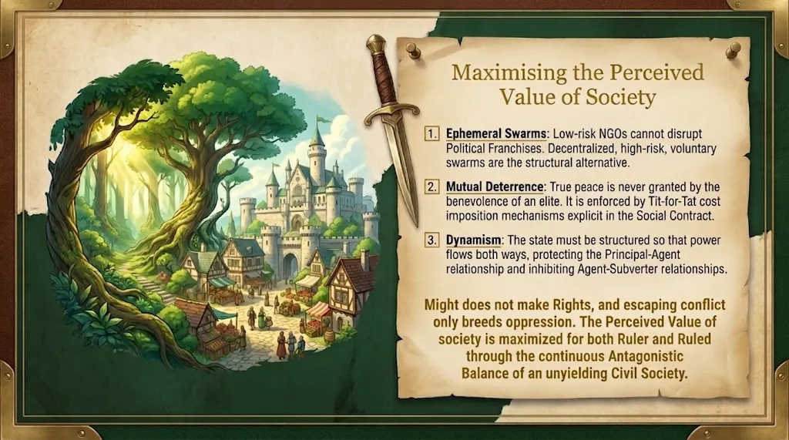
The ultimate goal of Game Theory for Rebels is not chaotic disruption, anarchy, or to form radical movements. The goal is to maximise the Perceived Value of society for both the Ruler and the Ruled populations, ensuring the prosperity of the nation.
Public action occurs through Solution Franchises, but citizens must realise that low-Risk Solution Franchises and institutionalised NGOs are fundamentally not structured to disrupt Problem and Corruption Franchises effectively.
The only structural alternative is the Ephemeral Solution Franchise, and this works best if individual franchises Cooperate to form Ephemeral Swarms. They are driven by Voluntary action, minimal delegation, Swarm Synergy, and public Goodwill.
By escalating the Risk of Problem and Corruption Franchises, Ephemeral Swarms pressure politicians into abandoning policies or solving the underlying problem just to save face and salvage what they can before moving on to franchises that have a lower Risk.
The absolute best outcome for any nation is mutual Cooperation between the Ruler and the Ruled, without the Ruler population Defecting to the agendas of Subverters.
If the Rulers get richer at the expense of the Ruled, they look and feel richer than they actually are. If the whole society is becoming wealthier, the rich don’t feel as rich as they could have. This gives rise to the Ruler’s Fallacy: the Ruler is tempted into Defecting to feel richer even if it is at the expense of his nation, but his entire society becomes richer if he Cooperates with it.
Tit-for-Tat reciprocity in a multi-round game is the single best Strategy to guarantee long-term mutual Cooperation. This is even the case in the Hawk-Dove Game and the Ruler’s Dilemma, provided your goal is to maximise shared value.
To preserve this equilibrium across generations, the Social Contract must explicitly enforce and protect Tit-for-Tat mechanisms. True peace and prosperity are never granted by the benevolence of a powerful elite. The mathematics of Mutual Deterrence is the only thing that ensures the Ruler does not Defect.
There must be a Dynamic relationship between the citizens and the state, power needs to flow both ways, and that requires the constitution to declare that leaders have no special privileges. Regardless of the motivation, history proves that special privileges end up as Subverter assets.
The notion that a state can be structured using Game Theory to ensure that the Principal-Agent relationship is protected and the Agent-Subverter relationship is structurally inhibited is called Dynamism, and we will focus on this after presenting the Ruler vs Ruled Simulation.
We will be looking at a Monte Carlo simulation of the Ruler vs Ruled game next, modelled as a multi-round Hawk-Dove game played out in various scenarios. The simulation is used to show that no matter what the variables are, Tit-for-Tat always produces the highest Prosperity Score for both Ruler and Ruled.

